Chapter 15

Scheduling for the Short Term

**Background**

Scheduling can be a fun topic because it is easy for students to relate to. In fact, instructors can introduce the topic by bringing up an all-too-familiar problem: A student has three assignments and a book report due this week, along with a major midterm—which course should she work on first? If chapter 15 is covered toward the end of the term, many students may well be behind in several of their classes by that time. A counter-intuitive result to share with them is that scheduling by the earliest due date (EDD) *may not* be their best chance to avoid a lot of lateness, particularly if they are behind already. Often SPT is the best way to catch up, even if it means sacrificing the grade in one course (or crying in the professor’s office until he or she gives them a break). If we think of all of the assignments as a set of fires, extinguish the small ones first before focusing attention on the big blazes.

This chapter has several quantitative techniques that can be completed by hand, as well as several potential software applications. Hopefully instructors can convey the importance of scheduling for all kinds of organizations and that it represents an important and mature research area. One example problem that instructors might mention is the *economic lot scheduling problem*, which attempts to combine the POQ model from Chapter 12 with some of the scheduling issues presented here. In particular, when multiple products must be produced using the same resource, the lot sizes need to be adjusted to ensure that enough units of all products are made in time to satisfy their respective demands.

Interested future managers can purchase whole books on scheduling techniques. Scheduling problems are combinatorial in nature; thus, solution times, even with computers, grow exponentially every time that a factor (such as a job) is added to the problem. Scheduling is also very dynamic—the ever-changing environment forces regular re-examination of schedules.

**Class Discussion Ideas**

1. When first introducing the subject, instructors could ask students to identify different types of scheduling problems in the real world. The list could easily fill a page and take several minutes to develop—the point being to get students thinking about the tremendous variety and prevalence of scheduling applications in existence, no matter what industry they will eventually work for. Examples to have handy in case of dead air include: factory (jobs on a machine, purchases and deliveries, workforce), university (assigning professors to classes, assigning rooms to classes, setting registration priorities), airlines (flights, connections, crews), hospitals (operating rooms, outpatient procedures, nurses), and the National Football League (games, referees). Discussions about scheduling the school sports teams can spark interest as well.

2. Before going over the sequencing priority rules covered in the text, instructors could ask students what they think good priority rules might be for sequencing jobs on machines or even for sequencing class assignments given a set that is due in the coming week. Usually students will eventually come up with the most popular four (probably not critical ratio), and they may have other ideas such as the bulkiest jobs or projects that take up the most space, the most profitable jobs, jobs from the most important customer, jobs from the customers who complain the loudest, jobs with the most perishable raw materials or that have the greatest chance of becoming obsolete, whatever the boss tells them to do, and jobs with economies of scope (for example, similar setups on the machine). Instructors could ask about the television show *MASH*, where, via triage, the most wounded patients were treated first. Triage had a fascinating caveat in the show, however, in that gut-wrenching decisions sometimes had to be made about severely wounded soldiers with less than a 50% chance of survival who might take, say, four hours of a surgeon’s time—in the meantime several less wounded soldiers might perish waiting for the surgeon to become available. Who should be worked on next? Finally, certain college sports schedules are dictated above all else by when the game can be aired on television. Other rules exist such as potentially alternating the home field against conference opponents, playing against the rival school at the end of the season, or even scheduling a home basketball game in another city in the state during holiday breaks when the students have left town.

**Active Classroom Learning Exercises**

1. A fun exercise can create some sort of assignment problem involving celebrities that make the news for doing crazy things or that otherwise get made fun of for various antics or characteristics. Fictional tasks could be created for these individuals that might draw upon some of their respective strengths or weaknesses. At this point the instructor can ask students to provide numerical ratings for the celebrities for each of the categories (say from 1 to 10, where 1 represents outstanding and 10 represents awful). As shown at the end of the chapter, the assignment problem can be rather easily handled by Excel’s Solver (or Excel OM or POM for windows). Instructors could have a solution program up and ready on the screen and then insert the students’ table into the software to determine the best assignment. Sensitivity analysis could see what happens to the assignments if either the ratings are re-examined or perhaps if a new (fictitious) scandal hits the news about one of the celebrities. Also, instructors can develop various scenarios showing that, for subjective ratings like this, it’s the differences *within* each category that drive the results, more so than the differences between categories. For example, Suzy might score a 1 in category A and an 8 in category B. Meanwhile Bob might score a 2 in category A and a 10 in category B. In this case, the optimal assignment is Suzy in category B and Bob in category A (total score of 10), implying that the overall best possible rating of putting Suzy in category A would not be assigned.

2. The widely used Lekin software mentioned in the chapter is available for free at www.stern.nyc.edu/om/software/lekin/download/html. Consider having the program showing on the screen during class. Let students generate different collections of jobs needing processing. Then try different priority rules on these sets of jobs. Record the results and compare the performance of the various rules. For those interested, the Lekin software handles other types of scheduling situations such as general job shops, which go beyond the scope of the text. Instructors could demonstrate some of these applications using Lekin.

**Company Videos**

1. *Scheduling at Hard Rock Café (4:35)*

This is a short video but packed full of interesting characteristics of a complicated problem that most students can relate to. The Hard Rock Café in Orlando, Florida, has 1100 seats and must try to schedule 160 servers fairly and effectively. The primary driver of employee scheduling is the sales forecast, which is based on prior sales, trends, seasonality, and known local events. Employees are then asked to provide preferences for work times, work days, and work stations. A linear program (Module B) solves the scheduling problem for Hard Rock, creating a daily schedule for each employee. The preference constraints are modified by seniority and a priority weighting from 1 to 9 assigned to each employee. The schedule also keeps the number of employees at a minimum during low-demand times of the day. Workers are allowed to swap shifts, but they seldom do so because the software takes care of most of their personal constraints. One result of the scheduling system is a turnover rate equal to one-half of the industry average.

Prior to showing the video, instructors could ask students to think about what factors Hard Rock Café in Orlando might consider when scheduling its 160 servers every week. Afterwards, discussion could compare the students’ *a priori* impressions with the considerations described in the video. Beyond that, instructors might ask students to share any positive or negative work schedule experiences that they might have had as an employee for a service firm. Then any students who had to create work schedules as managers could relate their experiences. What happened when an employee either refused to come in when requested or simply did not show up? How was absenteeism handled? Finally, some chain restaurants have regional or national offices create the employee schedules for the local franchise. What might be the advantages and disadvantages of such an approach?

**Cinematic Ticklers**

1. *The Simpsons, Season 2: “Bart Gets an F,”20th Century Fox Video, 2002 (1990-1991)*

If instructors are using student study schedule decisions to help illustrate scheduling issues, then they may want to show the opening scene from this episode. The students are presenting their book reports orally to class, but Bart has not read his book. He tries to fake his way through his report, but he gets caught when Mrs. Krabappel asks him to state the name of the pirate (in *Treasure Island*). Later on in the episode, Bart is trying to study, but he keeps getting interrupted (for example, when his father Homer asks him to stay up late and watch a movie together).

**Presentation Slides**

INTRODUCTION (15-1 through 15-8)

Slide 8: We’ve all been stuck at the airport at one time or another. Delta has worked hard to make such waits less frequent and less painful. Airline scheduling has been called “the Mother of all scheduling problems,” because the companies must schedule thousands of planes with interconnections daily, plus pilots and flight crews with all of their human resource constraints, plus local staff at each airport. This application is where mathematical programming really shines. The *static* scheduling problem is difficult enough, but the *dynamic* scheduling problem kicks in when a plane breaks down or Mother Nature gets nasty. One delayed plane can cause a ripple effect throughout the system. The interesting Global Company Profile in Chapter 15 describes how Delta handles the 10% of flights that are disrupted each year. The company has created a war room-like atmosphere to anticipate and react to potential problems. The estimated annual savings of $35 million paid for the “high-tech nerve center” in just one year.



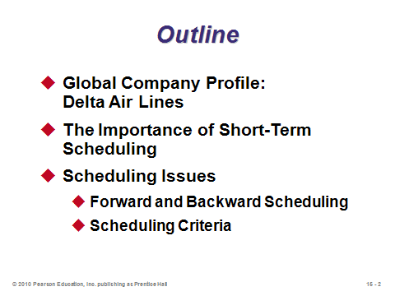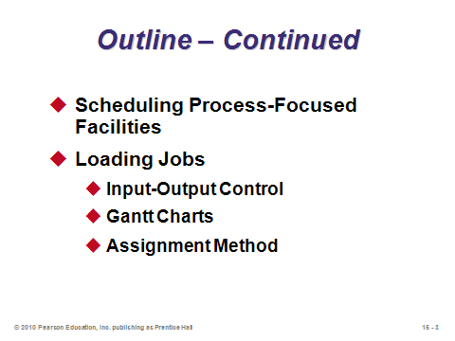

**15-1 15-2 15-3**

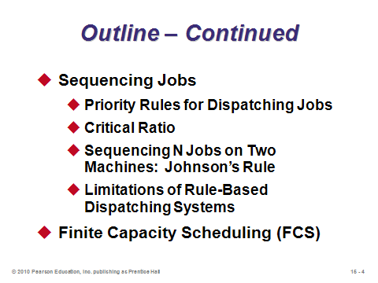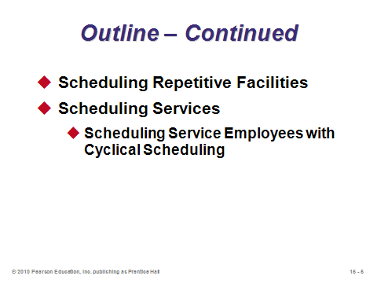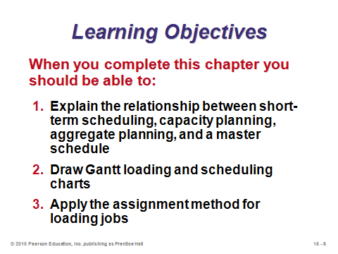

**15-4 15-5 15-6**

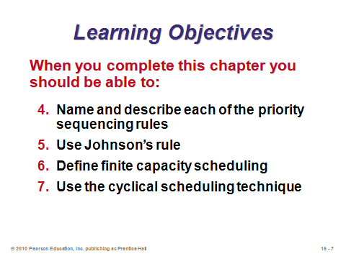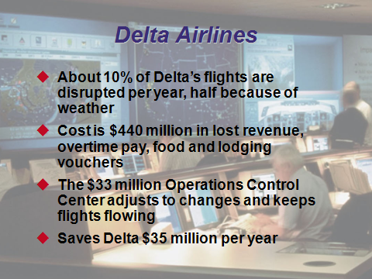

**15-7 15-8**

THE IMPORTANCE OF SHORT-TERM SCHEDULING (15-9 through 15-10)

Slide 9: This slide defines short-term scheduling, the focus of Chapter 15. After all of the higher-level planning that the book has discussed, we finally see how to determine *exactly* what is produced and when.

Slide 10: Good scheduling increases utilization rates on equipment, while producing items quicker and on-time more often.

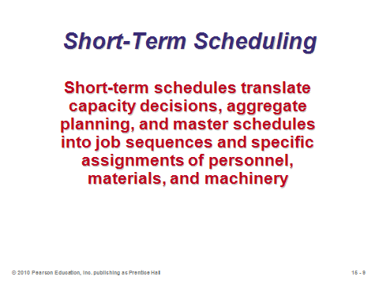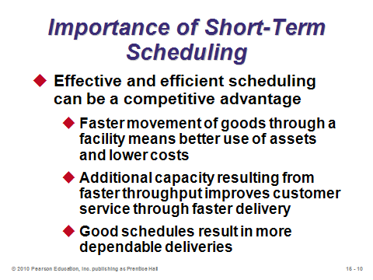

**15-9 15-10**

SCHEDULING ISSUES (15-11 through 15-18)

Slides 11-12: Companies schedule jobs (products or customers), resources (machines, rooms, and employees), and activities (maintenance, purchasing etc.). The resulting schedules depend upon the priorities that management has deemed important. Slide 12 (Table 15.1) provides examples of scheduling activities at five different organizations.

Slide 13: By this point in the book, students have been exposed to an array of planning functions at different levels of aggregation. This slide (Figure 15.1) does a nice job of showing where short-term scheduling fits in with the other planning functions.

Slides 14-16: Scheduling involves assigning due dates to specific jobs, but many jobs compete simultaneously for the same resources. These slides describe forward vs. backward scheduling. Forward scheduling (Slide 14) may be more appropriate in situations where customer orders arrive and the goal is to complete each order as soon as possible. Here due dates are not considered, causing some jobs to potentially be late. Backward scheduling (Slide 15), which may be more appropriate for repetitive manufacturing environments or for services with specific event times (a concert or a doctor appointment), attempts to produce a schedule that meets all due dates. However, the schedule may not be feasible given the available resources. Slide 16 informs us that the two scheduling approaches are often combined in an attempt to address the trade-off between schedules that are feasible given available resources and schedules that meet all customer due dates.

Slide 17: This slide is based on Table 15.2, which provides an overview of different processes and approaches to scheduling.

Slide 18: This slide identifies four important scheduling criteria. (Note that criteria 1 and 3 are often very highly correlated.) Other criteria may be used, such as minimizing the maximum lateness of any job, minimizing the average lateness for those jobs that are late, minimizing the number of late jobs, or some sort of fairness criterion for customers or employees. Determination of the most important criteria often drives which scheduling method to use.

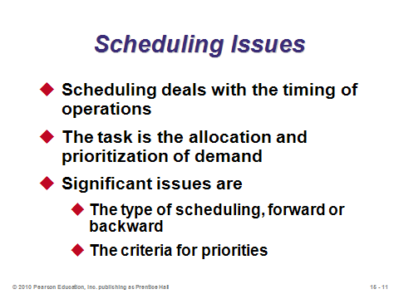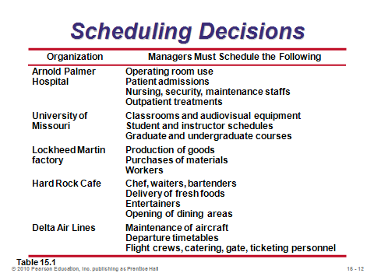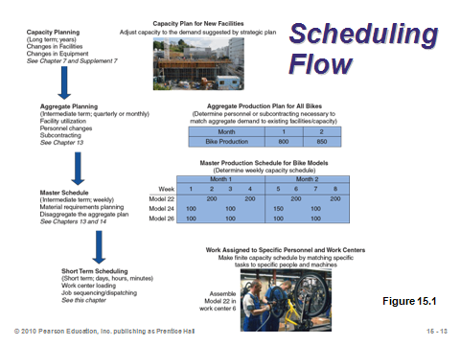

**15-11 15-12 15-13**

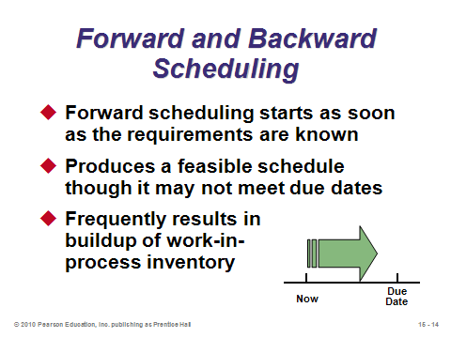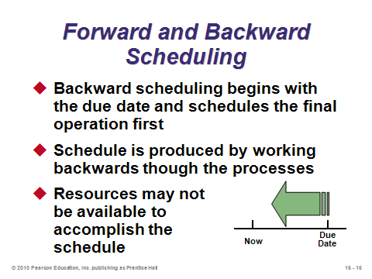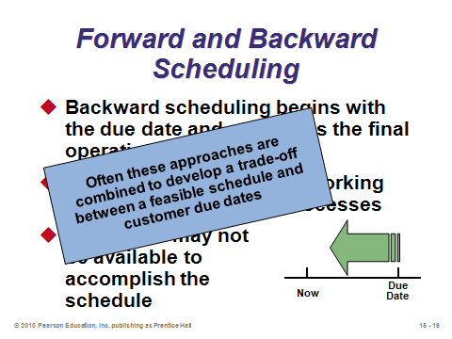

**15-14 15-15 15-16**

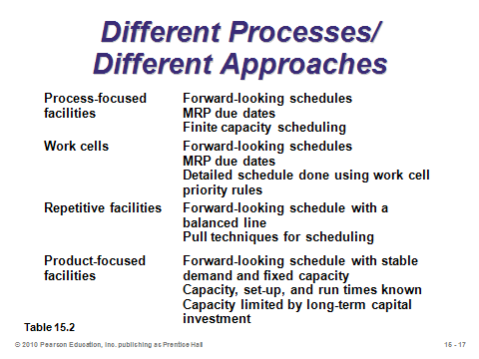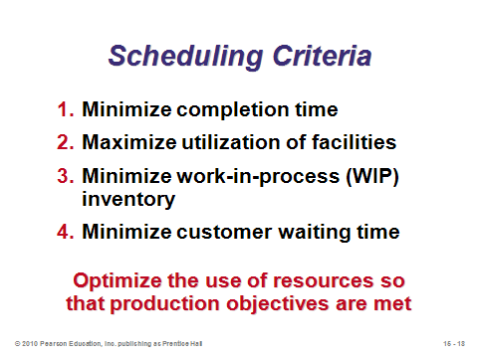

**15-17 15-18**

SCHEDULING PROCESS-FOCUSED FACILITIES (15-19 through 15-20)

Slide 19: On a daily basis, job shops tend to be more difficult to schedule than assembly lines or continuous flow facilities due to the variety of products produced, different routes through the system that these products take, and unstable demand. (The product-focused facilities might be more likely to utilize mathematical programming to set a weekly or monthly schedule, but once in place, these schedules seldom need to be updated—certainly not on a daily basis.) Slide 19 identifies the features that a good production planning and control system should incorporate.

Slide 20: This slide identifies the types of planning and control files that help to ensure that a scheduling system is accurate and relevant.

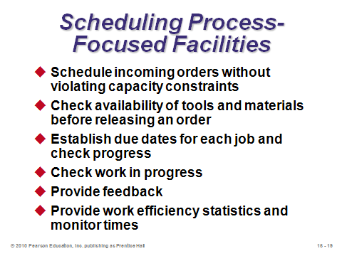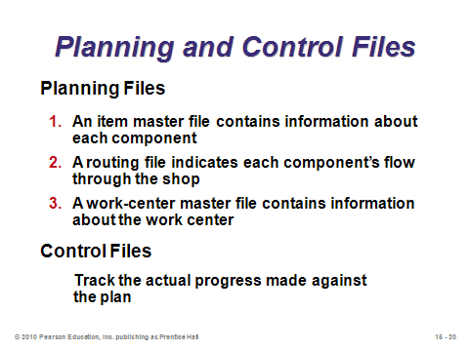

**15-19 15-20**

LOADING JOBS (15-21 through 15-36)

Slide 21: *Loading* means the assigning of jobs to work or processing centers. When loading is undertaken via the perspective of capacity, *input-output control* can be used. When loading is undertaken via assigning specific jobs to work centers, either *Gantt charts* or the *assignment method* of linear programming can be used.

Slides 22-25: Slide 22: Input-output control compares arrival rates of new jobs to the capacity of the facility to identify overloading (too much work) or underloading (too much idleness) conditions. ConWIP (*constant work-in-process*) cards can be used to aid input-output control. Such cards control the amount of work in a work center. Once the job has been completed, its ConWIP card is released and returned to the initial workstation, authorizing the entry of a new batch into the work center. Slides 23 and 24 (Example 1) illustrate the use of input-output controls. Note that the cumulative change in backlog is computed as the sum of the actual inputs minus the sum of the actual outputs. When this value moves too far from 0, managers should consider actions such as those identified in Slide 25. Changing work center input can be accomplished by (a) routing work to or from other work centers, (b) increasing or decreasing subcontracting, or (c) producing less (or more).

Slides 26-28: Slide 26: *Gantt charts* are visual aids that are useful in loading and scheduling. The charts show the use of resources, such as work centers and labor. A Gantt *load chart* shows the relative workloads over time of departments, machines, or facilities. Managers can shift work between resources when overloading or underloading appears. A Gantt *schedule chart* shows jobs in process, indicating which are on schedule and which are behind or ahead of schedule. Again, this type of chart provides management with a quick visual aid to look for areas requiring action. Slide 27 (Example 2) provides an example of a load chart (here metalworks and painting are completely loaded for the entire week), and Slide 28 (Example 3) provides an example of a schedule chart (here job A is one-half day behind schedule, job B was completed on time, and job C is ahead of schedule).

Slides 29-36: Slide 29 defines the *assignment method*. Importantly, it only applies when one and only one job (or worker) is assigned to one and only one machine (or project). (The assignment problem is actually a special case of the transportation problem seen in Chapter 13 and Module C, with demands and capacities both equal to 1.) Examples include assigning jobs to machines, contracts to bidders, people to projects, and salespeople to territories. Each assignment problem uses a table, such as the one illustrated in Slide 30 (prohibited assignments could be given a cost or time of infinity). The special structure of the assignment problem allows it to be solved by hand (using the *Hungarian method*). The solution steps are provided in Slides 31 and 32. Slides 33-36 go through a complete example of assigning three jobs to three typesetters (Example 4). The final solution assigns R-34 to person C, S-66 to person B, and T-50 to person A at a final cost of $25.

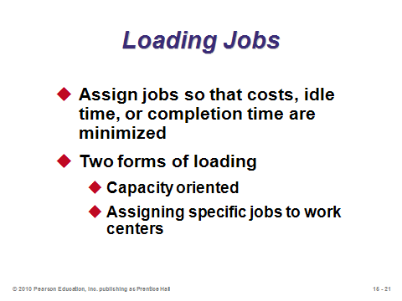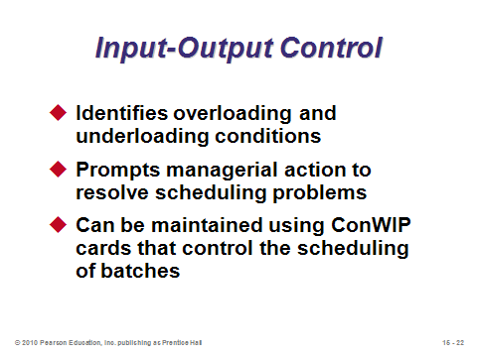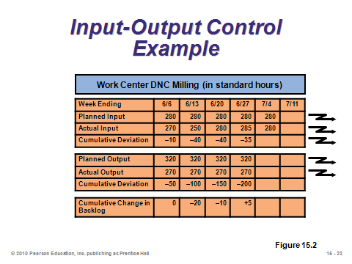

**15-21 15-22 15-23**

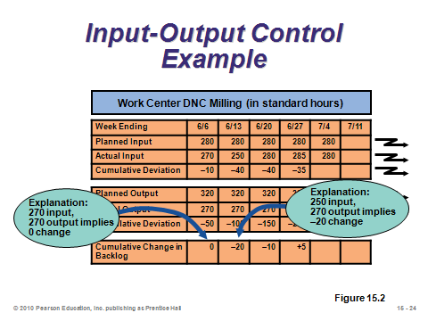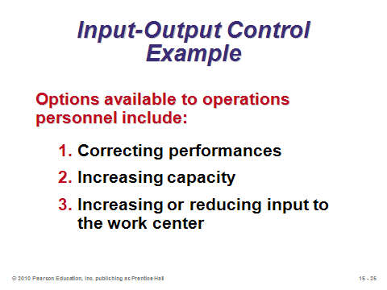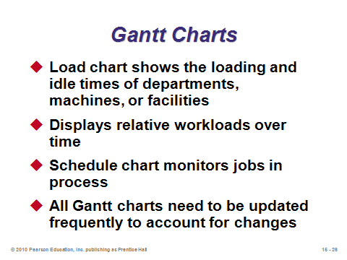

**15-24 15-25 15-26**

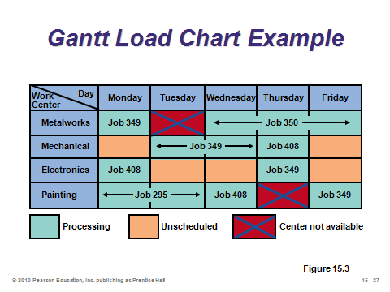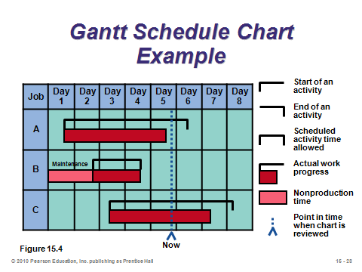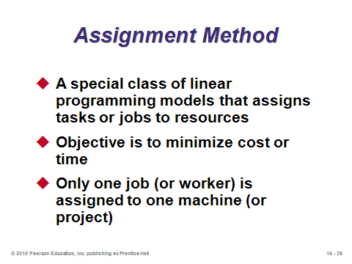

**15-27 15-28 15-29**

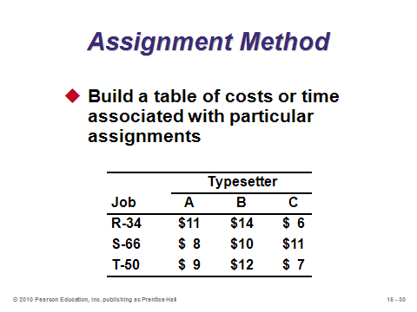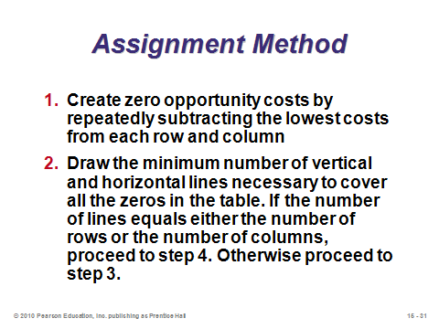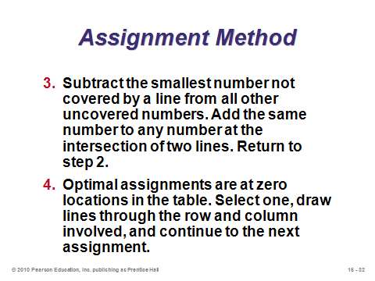

**15-30 15-31 15-32**

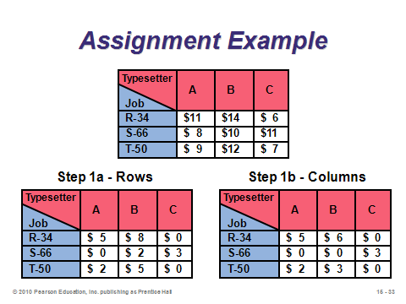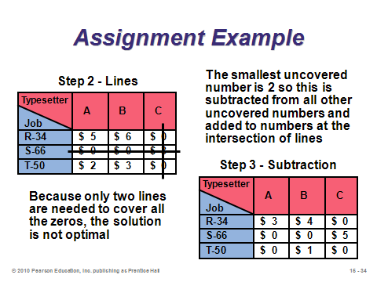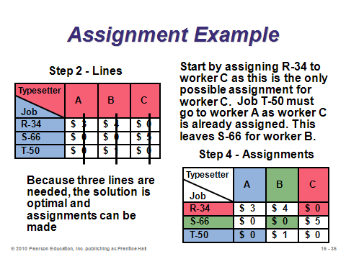

**15-33 15-34 15-35**

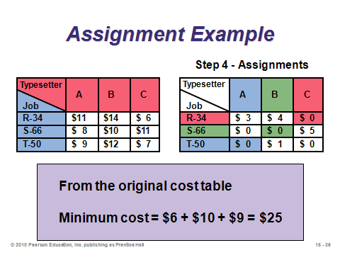

**15-36**

SEQUENCING JOBS (15-37 through 15-58)

Slide 37: Once jobs are loaded, managers must decide the sequence in which they are to be completed (also called *dispatching*). Students regularly perform sequencing in their own lives when they decide in what order to work on their assignments or which of several errands to run first. This slide identifies the four most popular priority rules for sequencing. A nice feature of sequencing is that, before any processing begins, different priority rules can be easily tested and the results compared. In fact, the rule used might change from one application to another depending on comparison results.

Slides 38-47: These slides apply the four main priority rules to the same set of jobs waiting to be sequenced. Note that *flow time* is defined as total time in the system (waiting plus processing). Job *lateness* is computed as Max(0, flow time – due date). (Here we assume no penalties for finishing early.) Clearly the lateness depends upon the sequence chosen. While total processing time will not depend upon the sequence, total flow time will because the flow time of any particular job in the sequence becomes part of the waiting time for *all* other jobs that follow. (This is why SPT is the rule that minimizes total flow time—overall waiting is minimized by getting the quick jobs finished right away.) Four measures of effectiveness are computed in these examples: (1) *average completion time*, (2) *utilization metric*, (3) *average number of jobs in the system*, and (4) *average job lateness* (see Slide 40 for the formulas). Note that the first three measures are completely correlated, i.e., the rule that performs best on one will perform best on all three. Slide 47 summarizes the results. In this example, SPT performed best on the first three measures (which will always be true), while EDD performed best on average lateness (which, surprisingly, is not always true).

Slide 48: This slide provides general comparisons for the four common sequencing rules. While SPT does not always minimize average lateness, it does *always* minimize average completion time. A suggestion: “When in doubt, use SPT.” FCFS usually performs at a decent average level, and it has the prime advantage of being fair to customers. FCFS may be particularly appropriate when customers can see the queue of jobs (think about sitting in a restaurant and then watching a group who just entered get seated before you, or think about potential unfairness that arises with multiple grocery store lines). Although EDD performed best on average lateness for Example 5 in the text, it is very important to emphasize that while EDD does minimize maximum lateness, it *does not necessarily* minimize average lateness or even number of late jobs. In fact, examples can be presented showing that EDD may perform very poorly on those lateness criteria. The basic idea is that if everything is scheduled via EDD, once the system falls behind, it may well remain behind for every single job that follows. This phenomenon is counter-intuitive and is one reason why students run into trouble meeting due dates during their semesters.

Slides 49-51: If average lateness is the most important criterion, the *critical ratio* technique may the best one to use. It’s in some sense a hybrid of EDD and LPT that examines the slack available for each job. Slide 49 provides the formula, and Slide 50 illustrates Example 6 from the text. A primary advantage of this technique is that the ratios can be recomputed after each job finishes, which potentially changes the remaining sequence after the slack conditions have changed. Slide 51 identifies benefits of the critical ratio technique in most production systems.

Slides 52-57: The sequencing rules discussed up to this point in the chapter all dealt with sequencing on one machine. But if jobs must pass through two different machines in the same order, *Johnson’s Rule* can be used to minimize the total flow time. The steps (Slide 53) may sound rather strange and illogical to students, but they are not too difficult to follow. Slides 54-57 clearly illustrate Example 7 from the text.

Slide 58: This slide identifies three limitations of using myopic rule-based dispatching systems. Nevertheless, schedulers often apply one of these methods at each work center and then modify the sequence to deal with a multitude of real-world variables. They may do this manually or with finite capacity scheduling software.

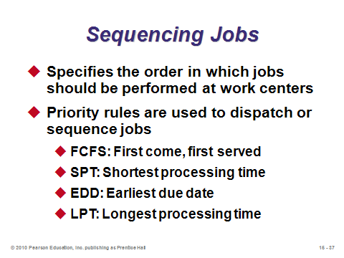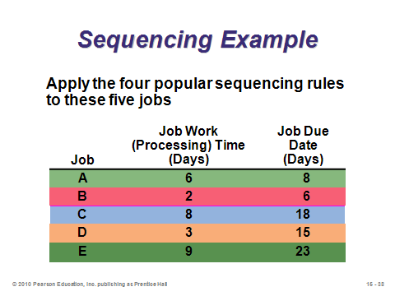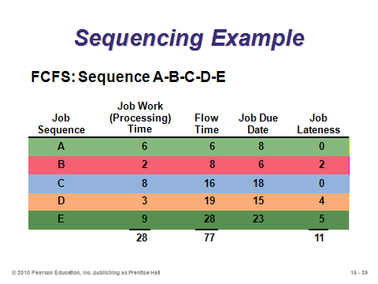

**15-37 15-38 15-39**

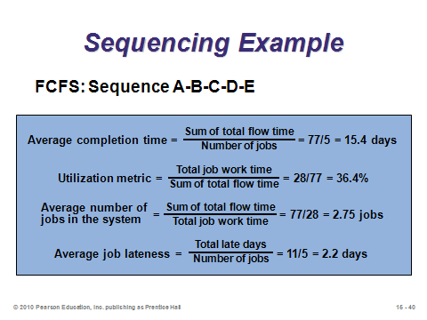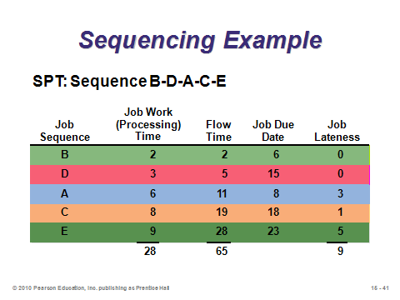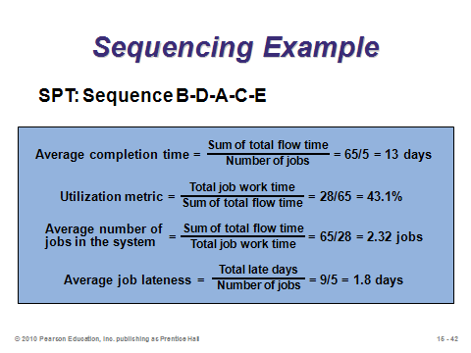

**15-40 15-41 15-42**

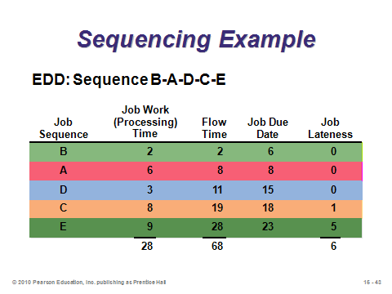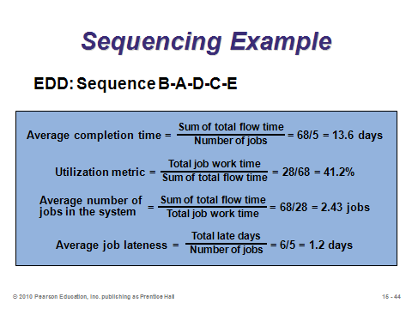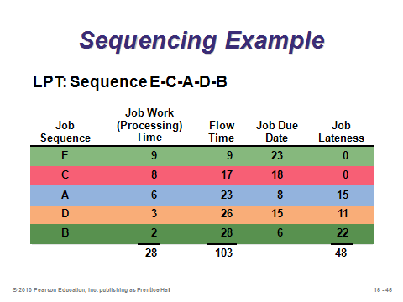

**15-43 15-44 15-45**

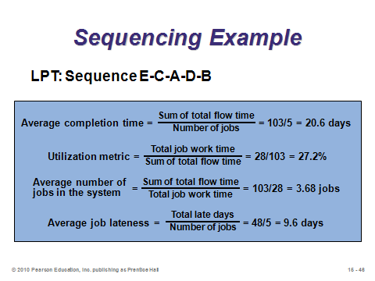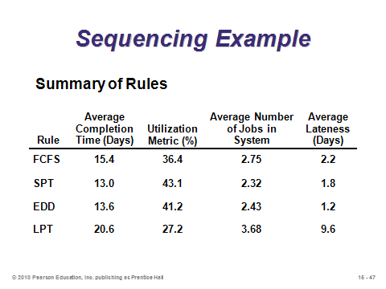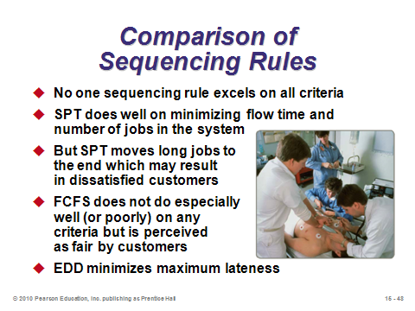

**15-46 15-47 15-48**

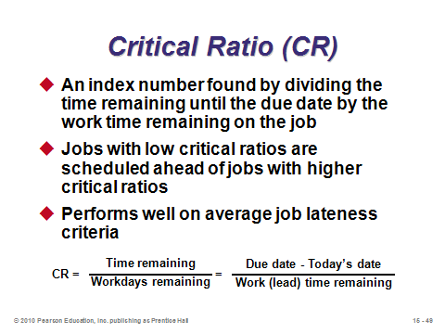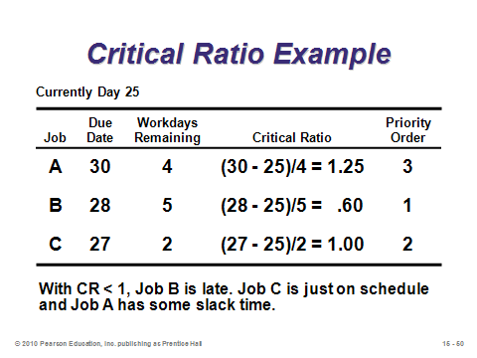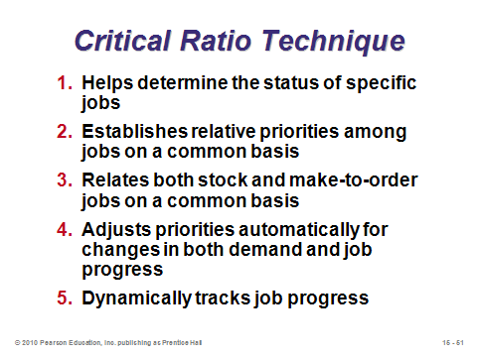

**15-49 15-50 15-51**

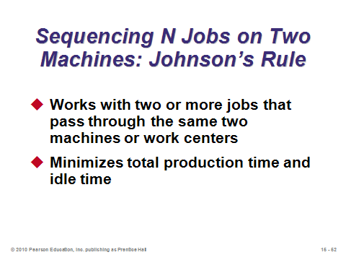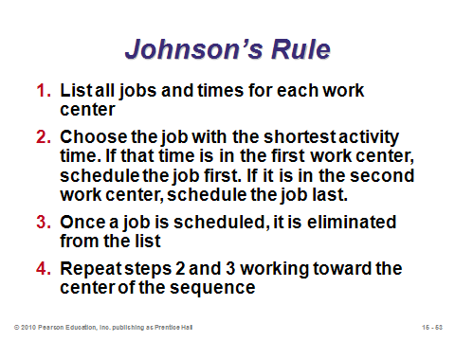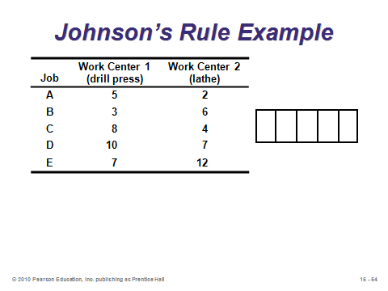

**15-52 15-53 15-54**

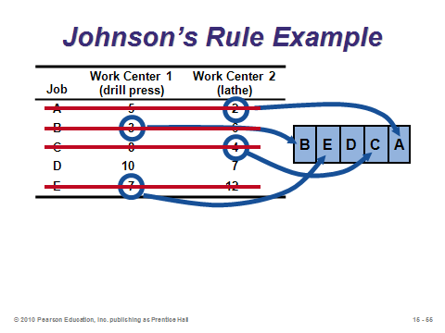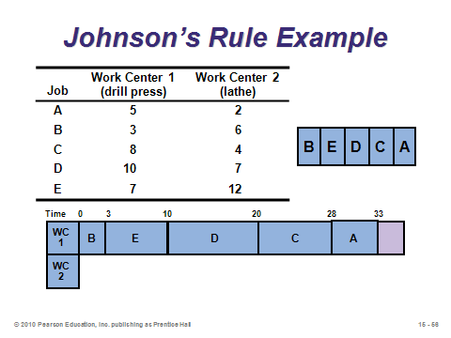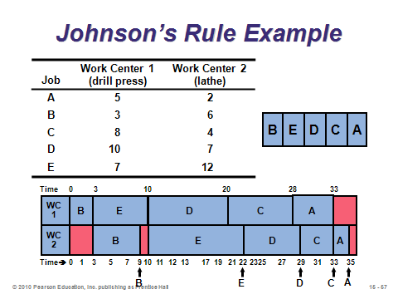

**15-55 15-56 15-57**

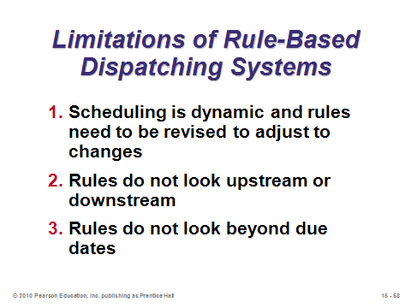

**15-58**

FINITE CAPACITY SCHEDULING (FCS) (15-59 through 15-61)

Slides 59-61: *Finite capacity scheduling* provides the scheduler with interactive computing and graphic output to help overcome the disadvantages of rule-based systems. FCS systems may allow virtually instantaneous schedule changes based on the most up-to-date information. Slide 60 (Figure 15.5) shows the different components that are combined to produce the Gantt chart output in FCS. Slide 61 provides a screen shot from the Lekin finite capacity scheduling software showing the data from Example 7 (the Johnson’s Rule example) in the text. This widely used software is available for free.

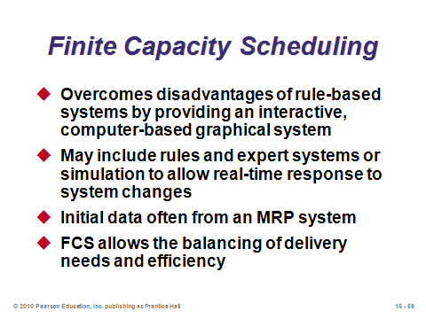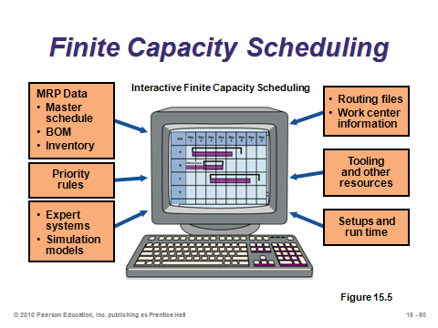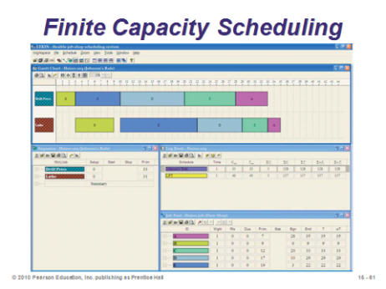

**15-59 15-60 15-61**

SCHEDULING REPETITIVE FACILITIES (15-62 through 15-63)

Slides 62-63: *Level material use* refers to the use of frequent, high-quality, small lot sizes that contribute to just-in-time production. These slides identify advantages to repetitive producers of implementing level material use.

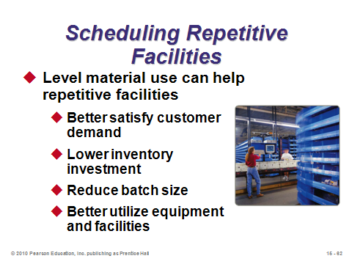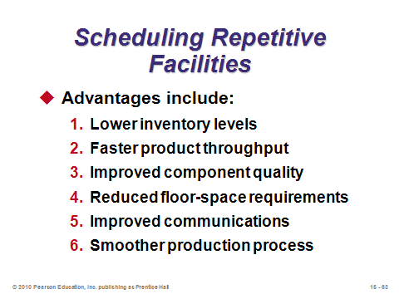

**15-62 15-63**

SCHEDULING SERVICES (15-64 through 15-77)

Slide 64: This slide presents several ways in which scheduling service systems differs from scheduling manufacturing systems. Some of these service characteristics appear in the Hard Rock Cafe video case associated with this chapter.

Slides 65-66: The complexity of scheduling services is exemplified by the industries highlighted in these slides.

Slide 67: As seen in Chapter 13, demand management techniques can be employed to smooth production, in this case easing the burden on the service company workforce scheduler.

Slides 68-77: *Cyclical scheduling* is utilized to develop a schedule with the minimum number of workers. Each employee is assigned to a shift and has time off. Slide 69 provides the steps used to address the staffing problem of Example 8 in the text. Slides 70-77 schedule employees one at a time until all staffing requirements have been met.

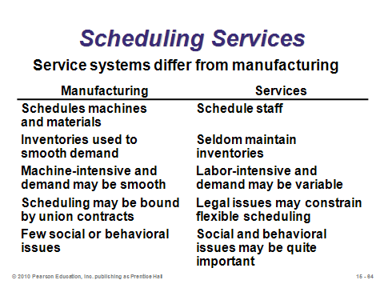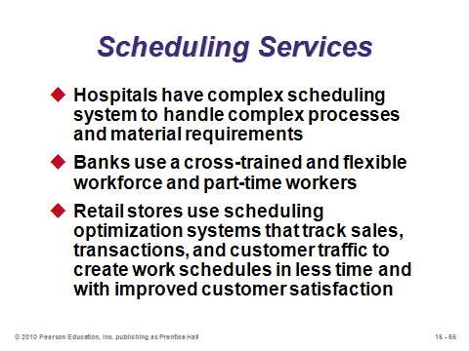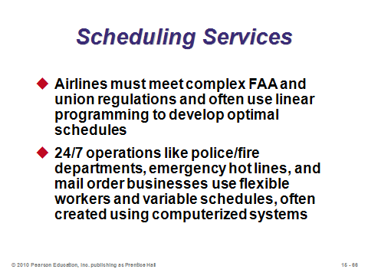

**15-64 15-65 15-66**

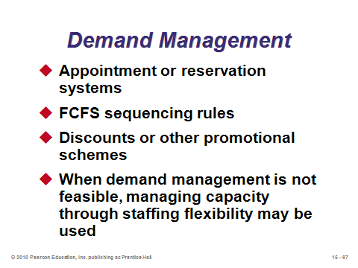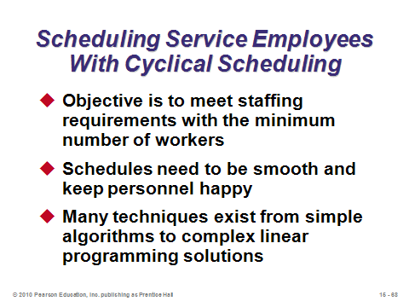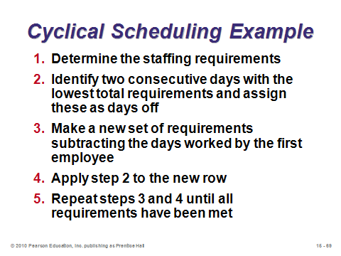

**15-67 15-68 15-69**

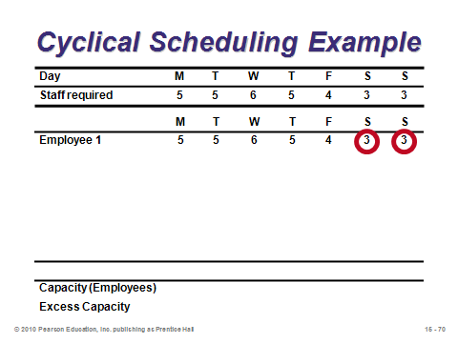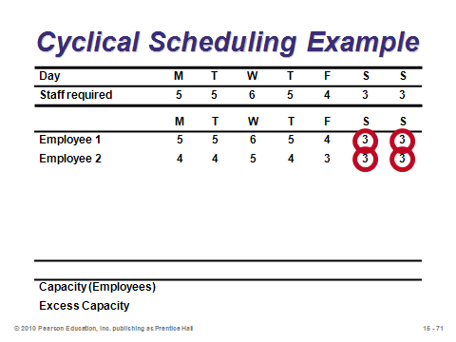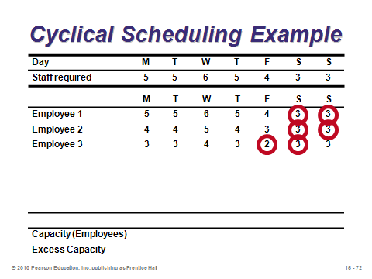

**15-70 15-71 15-72**

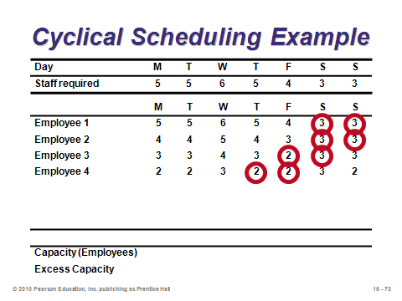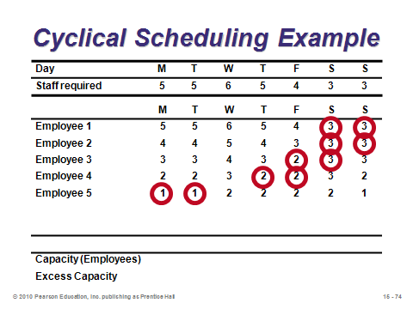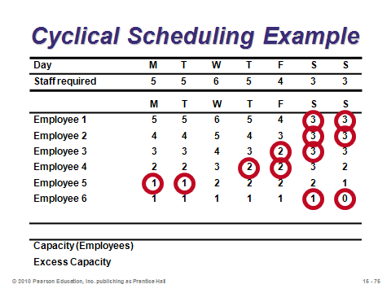

**15-73 15-74 15-75**

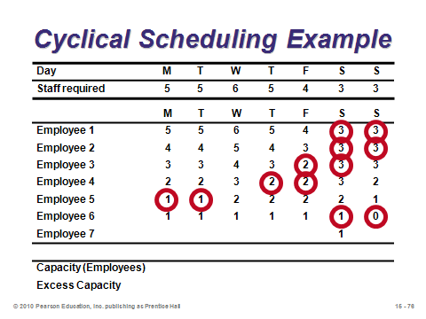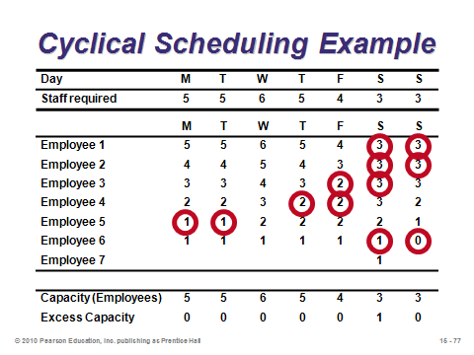

**15-76 15-77**

**Additional Assignment Ideas**

1. Have the students develop a Gantt chart for their daily activities from the time they get up in the morning until they go to bed at night each day for seven days.

2. Search the web and see if you can locate two or more scheduling software vendors. Can you identify what types of schedules and theories are used? How do they differ?

**Additional Case Studies**

Internet Case Study (www.pearsonglobaleditions.com/heizer)

* *Payroll Planning, Inc.:* Describes setting a schedule for handling the accounting for dozens of client firms.

Harvard Case Studies (http://harvardbusinessonline.hbsp.harvard.edu)

* *The Patient Care Delivery Model at Massachusetts General Hospital* (#699-154): Examines the implementation of a new patient care delivery model.
* *Southern Pulp and Paper* (#696-103): Describes a paper mill whose poorly scheduled paper machines are a bottleneck to the operation.

Richard Ivey School of Business (http://cases.ivey.uwo.ca/cases/pages/home.aspx)

* *Quantico Computerware, LTD.* (#9A94D014): The assistant plant manager was trying to decide on production scheduling and inventory management policies for the new computer diskette plant. Students are presented with three demand forecasts of increasing complexity as variability between and within product lines emerge.

**Internet Resources**

|  |  |
| --- | --- |
| CMS Software | www.cmssoftware.com/ |
| Finite scheduling software | www.asprova.com |
| GE Fanuc Automation | www.gefanuc.com |
| ILOG Model Development | www.ilog.com |
| MDSI, Shop Floor Communication | www.mdsi2.com |
| Production Scheduling | www.production-scheduling.com |

**Other Supplementary Material**

Commercial Software

Available from:

Network Dynamics Inc.

183 Sycamore St.

Watertown, MA 02472

(P) 508-879-9200

(E) info@networkdyn.com

http ://www.networkdyn.com/

* MPX -Windows, Teaching Package

Available from:

ILLOG, Inc.

1195 West Fremont Ave.

Sunnyvale, CA 94087-3832

(P) 408-991-7000

(F) 408-991-7001

http://www.ilog.com/index.cfm

* ILOG OPL Studio. Business process and optimization solutions.

Learning Game

The Job Shop Game by James R. Holt—Objective: The student will be able to understand how Drum-Buffer-Rope (DBR) scheduling applies to Job Shop environments

http://www.vancouver.wsu.edu/fac/holt/em530/Docs/JSGInstinfo.htm

Modeling Extension

Johnson’s Rule provides a method to schedule a set of jobs that must go through two machines in the same order. How about for three machines? It turns out that Johnson’s Rule can be easily modified to handle the three-machine case. The resulting solution is optimal under some conditions, and it usually represents a good heuristic otherwise.

Label the three machines A, B, and C. Create two *dummy machines* A′ and B′, where for any job, the time on machine A′ equals the time on machine A plus the time on machine B, and the time on machine B′ equals the time on job B plus the time on machine C. Apply Johnson’s Rule to A′ and B′.